1. **You must indicate the completed and uncompleted parts.**

Everything is completed

1. **Specify the parts that are missing, not working, and not working as desired.**

Everything is working fine!

1. **Place screen shots of the output created by your program for both insert and search operations for the given input in your report.**

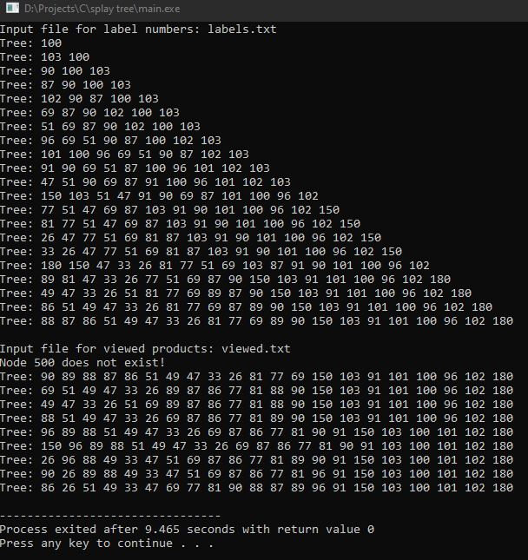

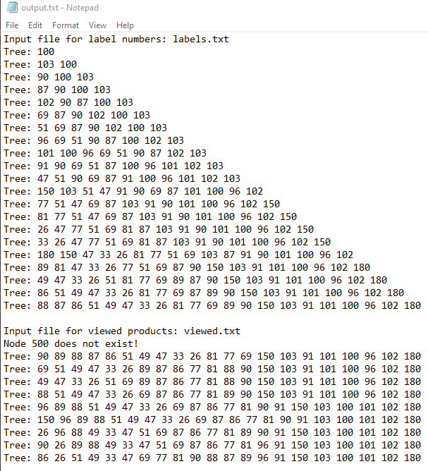

1. **You need to describe the structure you use to create the nodes of the tree. For example, if you used a struct for the node, you need to specify what the data fields in the struct are and what they are used for.**

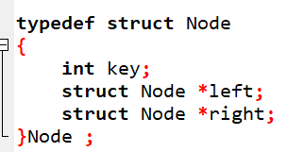

Key: used for number

Left,right: left and right node of current node

1. **Please indicate where and how you create the tree structure.**

Node* newNode(int key) : create a new Node

Node* insert(Node* root, int k): insert a node into the tree

1. **You need to specify which type of rotation you are writing a function for. For each rotation operation, you must write the name of the function you wrote and explain the task of the function and how it performs the rotation. Also, explain the function arguments.**

Node *leftRotate(Node* node): left rotate current node

Node *rightRotate(Node* node): right rotate current node

Zig – zig (left left):

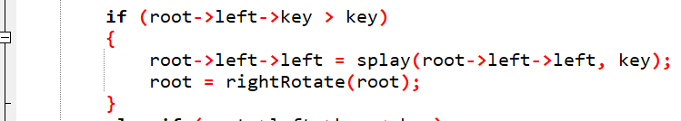

Zig – zag (left right):

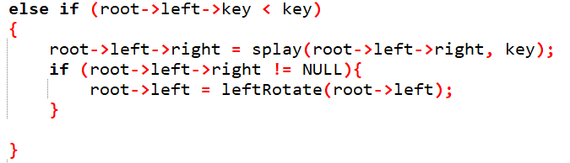

Zig-zag (right left):

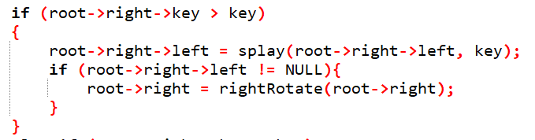

Zag-zag(right right):

